**LAB IN PSYCH  
WORD PRIMING  
TUTORIAL 5**

**DIYA BAROT**

**AU2120073**

**INTRODUCTION**

A word priming experiment assesses how a stimulus (prime) influences the response to a subsequent word (target). Priming can speed up or alter responses, revealing implicit memory and associations. By showing how earlier exposure to specific stimuli or information can affect a person's subsequent perception, memory retrieval, or behaviour, frequently without their conscious awareness, priming tests shed light on the unconscious encoding of memory.

We conducted this experiment to understand the process of unconscious encoding of memory and computing priming score.

**METHOD**

This was done in Two Routines

Routine 1: Study Phase

After Opening PsychoPy,

1. Add Text: Name = ‘Study_words, Start time = ‘0’, Stop = ‘8.0’’, and Text = $Study_words

with ‘set every repeat, Click OK

2. Add Slider: Name = Studyslider, Start = 0, Stop = ‘null’, Ticks (1,2,3,4,5), Labels =

“Familiar”, “Unfamiliar”. In Layout tab, Position[x,y] = (0.-0.3), click ok

4. Add Loop: Name = trials, loop type = random, nReps = 5, Conditions: insert .csv

conditions file with following:

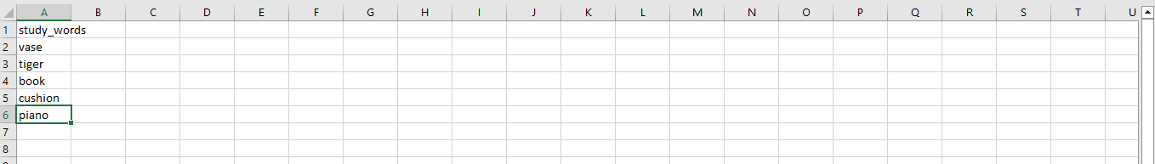

Interpretation: These words will have to be memorized by the participants before the

beginning of the test phase

Routine 2: Test Phase

5. Add Text: Name = ‘Test_words’, Start time = ‘0’, Stop = ‘10’’, and Text = $test_words with

‘set every repeat, Click OK

6. Add Textbox: Insert a text box to collect responses from the responses menu of the

components, name = test_textbox, start = 0, stop = null, tick mark the Editable

component, click ok

7. Add text: Add text, name = submit_text, Start = 0, Stop = null, Text = Click to Submit,

with ‘constant’ In the layout tab, position[x,y] = (0,-0.3)

8. Add mouse: Name = testmouse, start = 0, stop = null, End Routine on press = valid

click, Clickable Stimuli = $submit_text

9. Add loop: Add Loop: Name = trials_2 looptype = random, nReps = 5, Conditions:

insert .csv conditions file with following:

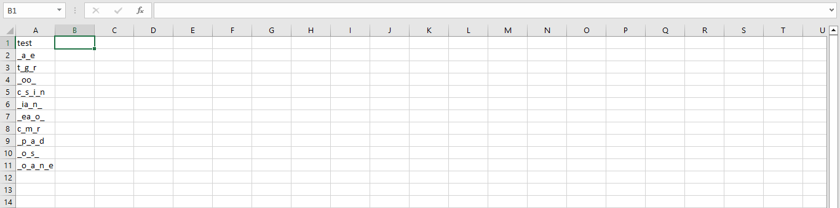

Test words will be displayed on the screen, and participants were required to complete

Them.

After checking, I ran the experiment myself and collected the scores, of 3 more participants.

**RESULTS**

The words used here were very general so all the participants were familiar with them. However, they took some time when they were tested on them while giving blank letters. But, the time taken was neglectable.

**DISCUSSION**

To design a face priming study, similar technique can be used. First of all, instead of text, we show the participants faces and their names for a certain duration. Later, to test their memory, we provide them with the faces and ask them to type their names under a certain duration.

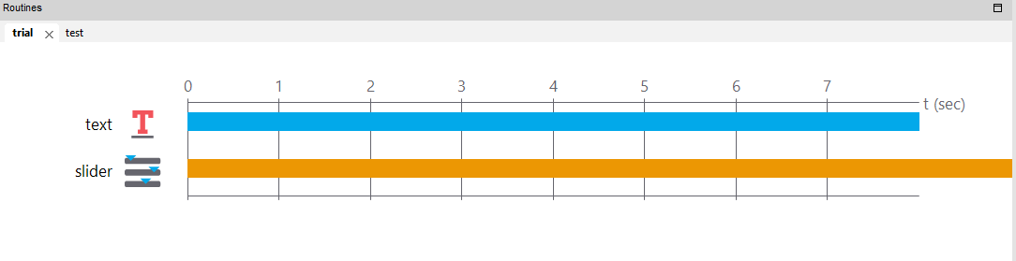

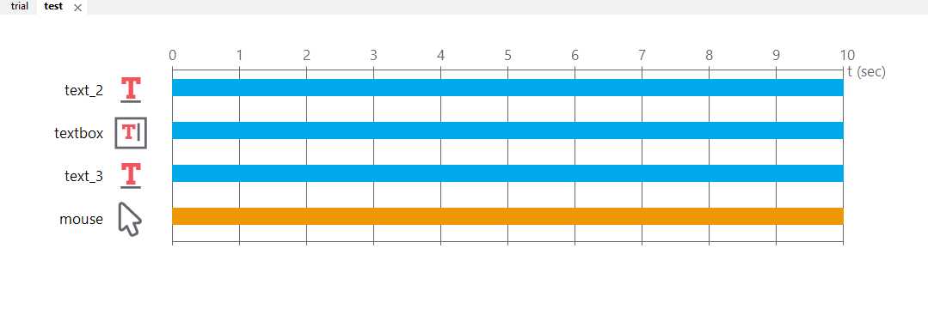

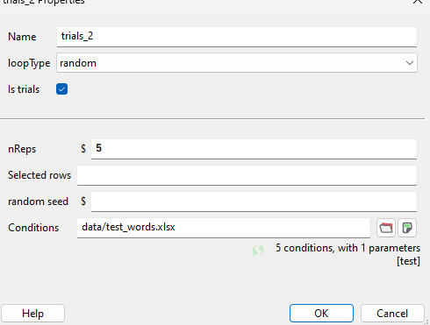

**LINK TO GITHUB**

[**https://github.com/diyabarotAU2120073/DIYABAROT/upload/main**](https://github.com/diyabarotAU2120073/DIYABAROT/upload/main)